INFORMACIÓN BÁSICA
NOMBRE DE LA PRÁCTICA:  Laboratorio filtros espaciales | PRÁCTICA No.:  3
ASIGNATURA:
Digital image processing
TEMA DE LA PRÁCTICA:
Filters 1

LABORATORIO A UTILIZAR:

Laboratorio de informática
CONTENIDO DE LA GUÍA
(Para elaborar por el Docente)
OBJETIVES.

- To apply design techniques of spatial digital filters.
- To analyze and compare the effects of different types of filters.
- To perform and design a frequency space domain filter.
- To compare the different effects of frequency space domain filters on the image.
INTRODUCTION.

The Matlab software haves some functions to transform between domain spaces. To understand the functionality of this commands please type HELP in the command window.

Transformation commands:

- dct2. Computes the discrete cosine transform in 2D.
- idct2. Computes the inverse discrete cosine transform in 2D
- fft2. Computes the discrete fast Fourier transform in 2D.
- ifft2. Computes the inverse fast Fourier transform in 2D.
- fftn. Computes the fast fourier transform in n dimensions.
- ifftn. Computes the inverse fast fourier transform in n dimensions.
- Radon. Computes the radon transform.
- Iradon. Computes the radon transform.
- Imnoise, Contaminates the image with noise.

THEORETICAL FRAMEWORK

Some neighborhood operations work with the values of the image pixels in the neighborhood and the corresponding values of a subimage that has the same dimensions as the neighborhood. The subimage is called a filter, mask, kernel, template, or window, with the first three terms being the most prevalent terminology. The values in a filter subimage are referred to as coefficients, rather than pixels. The concept of filtering has its roots in the use of the Fourier transform for signal processing in the so-called frequency domain. We are interested in filtering operations that are performed directly on the pixels of an image. We use the term spatial filtering to differentiate this type of process from the more traditional frequency domain filtering.
The process consists simply of moving the filter mask from point to point in an image. At each point (x, y), the response of the filter at that point is calculated using a predefined relationship. For linear spatial filtering, the response is given by a sum of products of the filter coefficients and the corresponding image pixels in the area spanned by the filter mask.

For the 3x3 mask shown in the result (or response) of linear filtering with the filter mask at a point (x,y) in the image is:
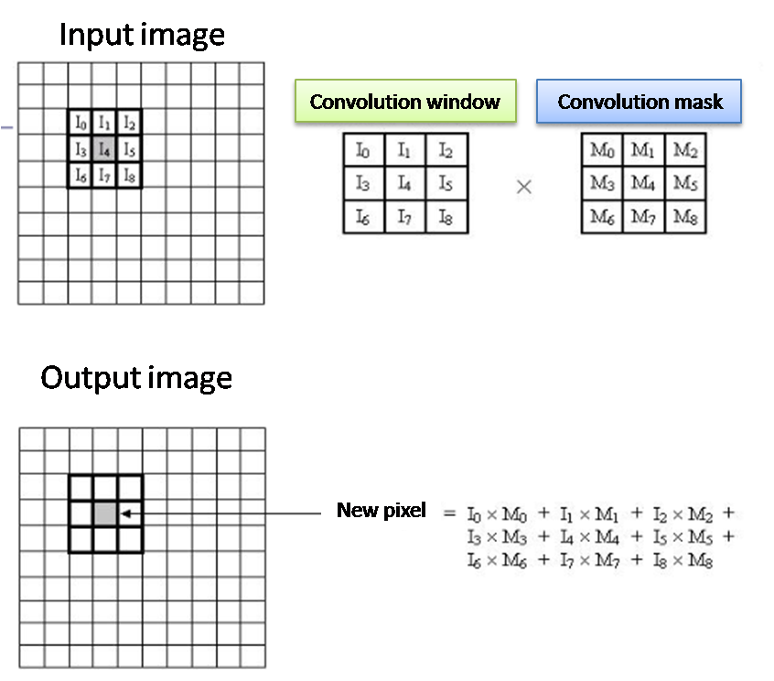
PREVIOUS KNOWLEDGE

- Read about 2D Filters in spatial domain.
- Read about 2D Filters in frequency domain.
- Read about Convolution in 2 dimensions.
- Read about 2D median filter

METHODOLOGY

- Masks. Design a function in matlab that applies a square mask of 3x3 in a digital image using the concept of 2D convolution. The function has the format: function [I Iout]=fmask(I, mask)
Where:
- Iout = is the Output image.
I = Is the input image.
mask = contains the coefficients for the convolution window.
Conditions:
- Take in to account the problem of management of borders, you can add zeros or avoid the edge information.
- You cant use native matlab functions to do the convolution.
- Read a sample image and use the imnoise command and generate a 3 test image, with Gaussian, salt & pepper and speckle noise.
MATERIALS AND EQUIPMENT

Materials | Reactivos | Materiales Estudiante
Matlab (image processing toolbox)

PRECAUTIONS AND MATERIAL MANAGEMENT.

- Please take care of the computer assigned to you.
- Please do not enter food an liquids.
- Please do not enter your bagpack.

Exercises
With your own created function:
- Apply a mean filter on the 3 test images and try to remove al possible noise, show the results.
- Apply a median filter on the 3 test images and try to remove al possible noise, show the results.
- Apply a basic High band pass filter and one High boost, show the results.
- Apply the gradient masks (sobel, prewit, Roberts), show the results.
- Apply the laplacian operators over the tests images and show their results.

BIBLIOGRAFÍA RECOMENDADA.

[1] Digital Image Processing,
Gonzales, R.C., Woods, R.E
2ed, Prentice Hall, 2002

ELABORÓ  (Personas que elaboraron la guía) | REVISÓ  (Director de Programa o Área) | APROBÓ  (Laboratorios)
Firma Jorge Andres Alvarez Triana  Nombre :  Fecha:8/09/2016 | Firma  Nombre : Diana Paola Ovies Bernal  Fecha: | Firma  Nombre :  Fecha:

INFORME DE LABORATORIO
(Para elaborar por el Estudiante)
ESTUDIANTES: | GRUPO:
ESTUDIANTES: | NOTA:

CARRERA:

Formule tres objetivos que desee cumplir con la Práctica de Laboratorio
El estudiante formulará desde su conocimiento los objetivos para la realización de la práctica

Elabore un Mapa conceptual del tema a tratar en la Práctica de Laboratorio.

RESULTADOS
Incluir tablas, diagramas en la que los estudiantes puedan ir consignando los datos y observaciones obtenidos en la práctica

CAUSAS DE ERROR Y ACCIONES PARA OBTENER MEJORES RESULTADOS:

El estudiante formulara las posibles causas de error comparando sus resultados experimentales con los teóricos

CONCLUSIONES

El estudiante realizara una serie enunciados que respondan a los objetivos que el mismo formuló, basados en el desarrollo de la práctica.
QUESTIONARY

- Justify the algorithm used to rotate the matrix image.
- Justify the algorithm to apply bitslicing.
- Justify the algorithm to reduce the spatial resolution.

APLICACIÓN PROFESIONAL DE LA PRÁCTICA REALIZADA

BIBLIOGRAFIA UTILIZADA
[1] Digital Image Processing,
Gonzales, R.C., Woods, R.E
2ed, Prentice Hall, 2002

